Modules and Functionalities Of Tender And Contract Management System (TCMS)

1. TCMS is a windows application developed using Microsoft C# .NET (Framework 3.5) and SQL Server 2008 database software products.
2. TCMS application enables the user to create the project and update the data related to different stages of the project. For example, Prepare Tender Document, Tendering, Tender Evaluation and Award, Contract Process and Post Contract stage.

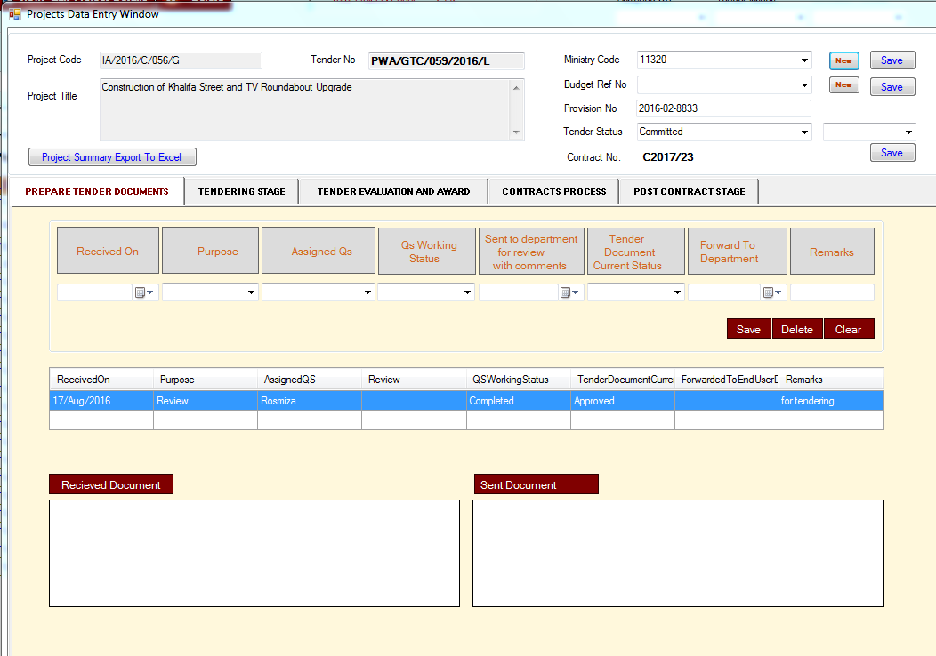

1. There are admin and non-admin users in TCMS application.
2. The admin user has the privilege to create other users and assign different types of access rights. For example, to access specific stages and modules of the project.
3. There are five types of modules in TCMS application, Admin, Contacts, Projects, Reports and Documents.
4. Inside Admin module there are four sub-modules. For example, Users, Security Profiles, Security Codes, and Email Alerts.
5. Users module can enable user to “Add User”, “Edit User”, “Delete User”, “Add Security Profiles”, “Update Security Profiles”, “Delete Security Profiles”, “Add/Edit Tender Types” and Add Users to different committees for receiving emails for “Tender Cancellation”, “Expiration of Evaluation”, “New Tender Number Assignment”, “Change in Tender Closing Date”, “Transfer of Tender To Another Committee” and “Expiration of Tender Validity” categories.
6. Report module consists of following twenty reports :-
   1. Tender Tracking Reports
   2. Tender Committee Reports
   3. Tender Committee Award
   4. Project Tracking Reports
   5. Tender Committee
   6. Tender Bond Tracking
   7. Committed Contracts
   8. Work Order Reports
   9. Qatari Share In Company
   10. Total Tender Approval Days
   11. Contractor Details
   12. Staff Job Tracking Details
   13. Awarded Tenders
   14. Contractor Qatari Share
   15. Company Participation In Different Tenders
   16. QS Working Status
   17. List Contracts
   18. Contract Values
   19. Projects Pre and Post Stage Records
   20. Companies Contracts Information

The above reports can be generated based on the different parameters provided by the user for example Department, Affairs, Fiscal Year, Tender Committees, Tender Stage, Type of Tender, Tender Status, Type of Contract and Start and End Report Date. User can export the reports in excel format.

1. Contacts module can enable user to Add, Edit, set the status of the company to active or in-active, Search the company and Export the companies information into an excel file.
2. Contacts module can enable user to Add, Edit and Delete user information. Search Contact information based on Contact Name, Job Title and company name.
3. Documents module will display the list of all the documents (send and received) attached by the user in various projects. User can search the documents based on the Subject, Reference Number and Project Code.
4. All Projects module consists of ten sub-modules namely Projects Group per Contract, Projects Group per Tender, View Successful Bidders, Ongoing Contracts, Inactive Contracts, Archives, Current Day Closing Tenders, One Month Back Closing Tenders, Running Tenders and Deleted Projects.
5. Projects module enable user to “Add New Project”, “View/Edit Project Details”, “Delete Project”, search projects based on Project Code, Project Title, Tender Number, Current Stage, Tender Status, Type of Tender, Tender Committee, Type of Contract, Contract Number, Fiscal Year, Department, MozanahID and assigned staff.
6. Projects Group per Contract will display all the projects based on particular access rights assigned to the user including Contract Number information per project.
7. Projects Group per Tender will display all the projects to the user which belongs to Engineering and Business support department. In this sub-module, in addition to common searching criteria related to projects, user can search the projects based on Search Project creation date and Search Last Modified Date types. Under these types user can Search by Creation Date, Search by Last Modified Date and Search by Year.
8. View Successful Bidders sub-module will display all the projects with Tender Status not equal to “Re-Tender”, “Transferred to Other Committee”, “Archive”, and the project is under “Contracts Process” or “Post Contract Stage”, and the Contract Number associated with the project should not be equal to “Framework” or “Work-Order”. By clicking on Project Code hyperlink user can open the project and navigate to “Tendering Stage”. User will click on “View Bidders” button to view the list of successful and rejected bidders.
9. Ongoing Contracts sub-module will display all the projects with any Contractor whose status is On-going.
10. Inactive Contracts sub-module will display all the projects with any Contractor whose status is not On-going (or other than On-going).
11. Archives sub-module will display all the projects whose status is Cancelled, Re-Tender, Transferred to Other Committee and Archive.
12. Current Day Closing Tenders sub-module will display all the projects whose Tender closing or modified date is current date or today’s date.
13. One Month Back Closing Tenders sub-module will display all the projects whose Tender closing or modified date comes under last one month.
14. Running Tenders sub-module will display all the projects whose Tender closing or modified date is equal to or greater than today’s date.
15. Deleted Projects sub-module will display all the projects whose “Is-Deleted” column value is set to one.
16. Dashboard of TCM consists of charts which display information for Number of Tender Documents Approved Each Year, Total Projects per Tender Status, Number of Tenders Each Year, Total Value of Tender Awards per Committee (QAR Millions), and Tender Documents under Preparation.
17. The Project in TCM application consists of five stages these are Prepare Tender Document, Tendering, Tender Evaluation and Award, Contracts Process and Post Contract stages.
18. Except Post Contract stage, user can attach Send and Received documents. Prepare Tender Document stage allow user to enter Received-On date, Purpose, Assigned-QS, QS Working Status, Tender Document Current Status, Forward to Department and Remarks information.
19. Tendering stage allows user to enter Tendering Received On date, Tender Issued By, Comments from Department, Send to Public relations dept. for advertisement, Tender Issue Date, Tender closing and modified date, remarks, who is eligible for tendering (Local, International and Joint Venture), and Tender Bond and Document fees.
20. User can add bidders to the project from Tendering stage. By clicking on “Issue a Tender” button.
21. Users can view the details of added bidders by clicking on “View Bidders” button.
22. Users can also generate the report (Tender Collection) on the details of added bidders in pdf format by clicking on “View Report” button.
23. Inside the Window form of “View Bidders”, user can Edit or Delete the information of the bidders. However, Edition or Deletion operations, depends on access rights assign to the user.
24. Through this form user can generate the report on bidders in excel and pdf formats.
25. Through this form user can Email Circulars to All Bidders.
26. There are six project types namely Public Tender, Direct Order, Limited, Re-Tender, Pre-Qualification and Auction.
27. Only for Direct Order and Limited projects both “View Bidders” and “View Short-List” functionalities are available. For other project types only “View Bidders” functionality is available.
28. Information related to project’s Tender Evaluation and Award is entered through Tender Evaluation and Award stage.
29. This stage contains Tender Open, Document Received from CD, Technical Evaluation, Technical Tender Review, Financial Evaluation, Financial Tender Review, Tender Award Approval, Tender closing and modified dates. It also contains Number of meetings, remarks, Tender Validity and Tender Bond Validity dates information. It also contains Successful bidder information, awarded amount, Date of letter of award, budget amount and estimated cost.
30. Tender Evaluation and Award stage enables user to enter information about the tender submission details related to bidders of the project. By clicking on “Tender Submission” button user can enter the details of the tender submission or re- submission by the bidders. TCM application will allow user to issue receipt of Tender Submission in pdf format to the bidder of the project.
31. Based on access rights users of TCM application can also export the details of submission by the bidders in excel or pdf format.
32. From Tender Evaluation and Award stage based on access rights users can create new “Work Order” for the project. Work Orders are extra work related to the project. A work order may have a Contract Number associated with it.
33. Based on access rights users can delete the work order. Similar to Tender Submission functionality user must issue tender submission receipt to the bidder of the “Work Order”. For that user has to select the work order and then click on the “Work Order Tender Submission” button.
34. Fourth stage of the project is “Contracts Process”. Through this stage user can enter Contracts Process information related to the specific bidders of the project. This include “Handled By”, “Received of Award Document”, “Request Department to provide start date”, “Start Date Received”, “Notice Send to Tenderer to Sign”, “Due Date of Submission of Bond and Sign”, “Date of Sign Contract”, “Sent to Dept. for Sign.” etc.
35. Fifth stage of the project is “Post Contract”. This stage contains addition information related to the bidders. For example Contract Start and Finish dates, performance bond expiry date and Contract Status.
36. On the click of Bidder name a new window will open, which will allow user to add or edit the details related to the contract on which the successful bidder will work.
37. On the click of “Add Variation Order Details” button TCM application allows user to enter details related to variation order.
38. On the click of “Add Site Instruction Details” button TCM application allows user to enter details related to site instruction.
39. User can export the Summary of all the five stages of the project in excel sheet.
40. Based on access rights users can assign Ministry Code, Budget Ref. Number and Provision Number.